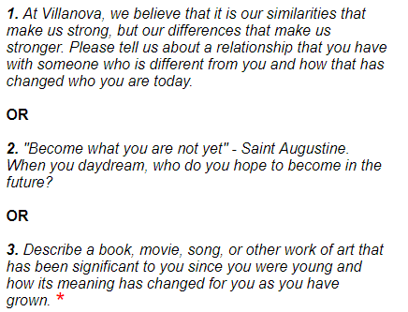

*3. describe a book, movie, song, or other work of art that has been significant to you since you were young and how its meaning has changed for you as you have grown.*

I clicked “place the order” button again, for some clothes I liked. That time, I promise, I think I did not make a sudden decision as I had longed for those stuff for a long time. Then I checked my bank balance and record, and was shocked by the result,

Greedy.

Did not talk,

Respect among people

To study in the United States had been my dream since junior high school, full of courage and hope, I stepped on the land of the US, but metamorphosis, immaturity and timid was accompanying me. For sure, fear and resistance to the new environment came first during my first several months in United States